Exercise 1 | Network Segmentation and Containment
Objective
In this exercise, you will simulate how network segmentation and firewall rules support incident response. You will move from a flat network to a controlled and segmented environment and simulate quarantining an infected system.
Windows 10 VM IP address
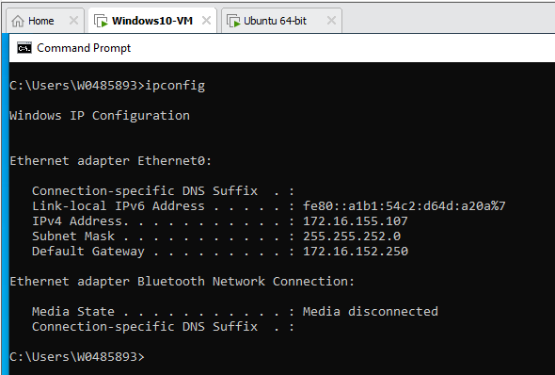
Ubuntu 24.04 VM IP address
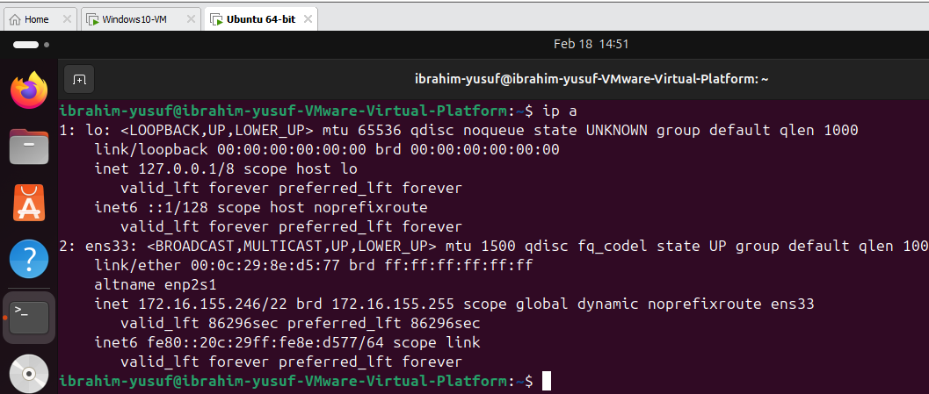
Scenario
Your company currently has a flat network. A ransomware infection has been detected on a user system. Your goal is to simulate how security teams use segmentation and firewall rules to contain an attack.
Part 1 – Verify a Flat Network
A flat network allows systems to communicate freely.
Step 1
Ping sent to Ubuntu VM IP address to test connectivity
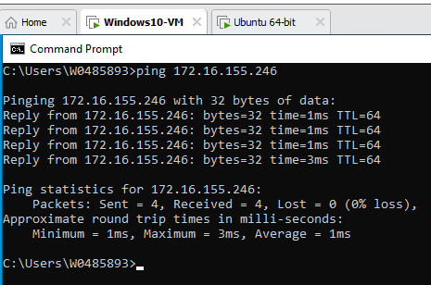
Step 2
Ping sent to Windows 10 VM IP address to test connectivity
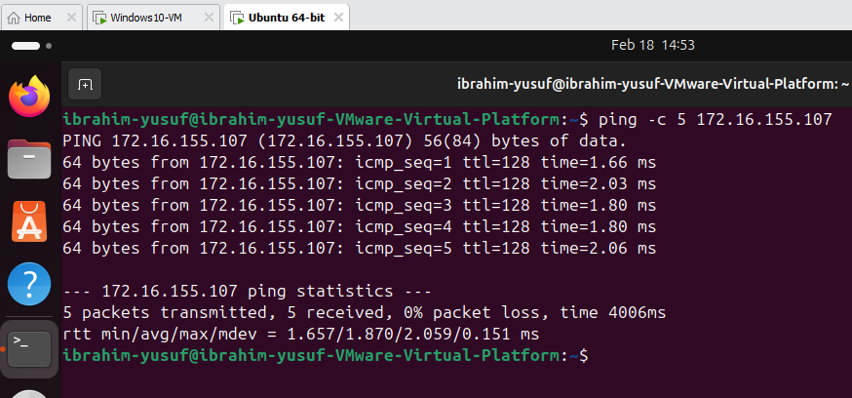
The Both systems communicated with each other without any restriction.
Questions
- Why is this considered a flat network? Because both the windows VM and Ubuntu VM can communicate directly with each other without any form of restriction, filtering, or segmentation.
- What risks does this create during an attack? If a system gets compromised by malware or ransomware, the attacker can easily scan the network, discover other vulnerable systems, and propagate the attack across multiple machines without restriction.

Part 2 – Simulate a Firewall Between Network Segments (KB Article)
In a real environment, firewalls sit between VLANs or network zones. You will simulate this using Ubuntu’s firewall.
Step 1 – Enable the firewall
On Ubuntu, run:
sudo ufw enable
Check the status:
sudo ufw status
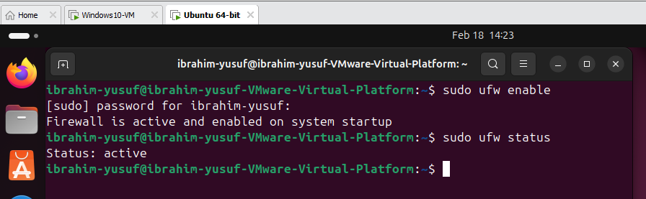

Step 2 – Set default firewall rules
Run:
sudo ufw default deny incoming
sudo ufw default allow outgoing
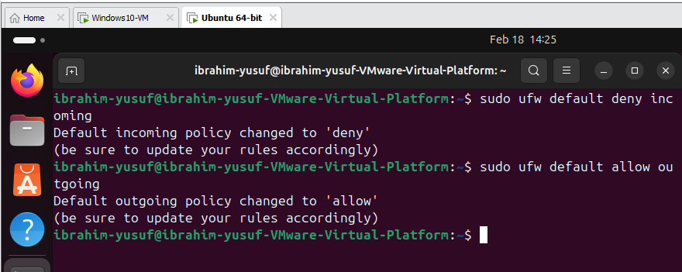

Step 3 – Test connectivity again
From Windows, attempt to ping Ubuntu.
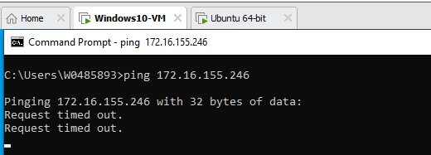
Questions
- What changed after enabling the firewall? After enabling the firewall and setting the default rule to deny incoming traffic, the Ubuntu system no longer responds to ping requests from the Windows system. This indicates that incoming network traffic is now being filtered and blocked.
- How does this simulate placing a firewall between network segments? Because it introduces controlled communication between systems. The firewall acts as a security boundary that restricts unauthorized access between network zones.

Part 3 – Allow Limited Access Between Segments
Security teams allow only required communication between zones.
Step 1
Allow SSH access from the Windows system only:
“sudo ufw allow from 172.16.155.107 to any port 22” to allow SSH access
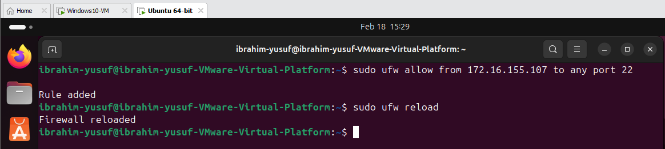
Step 2
From Windows:
- Try to ping Ubuntu
Ping sent to Ubuntu VM from the Windows VM
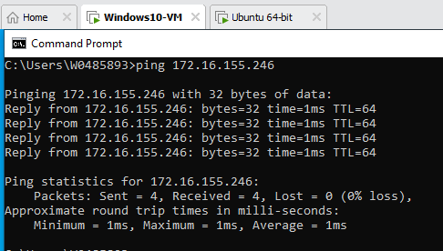

Connecting using SSH from my Windows VM
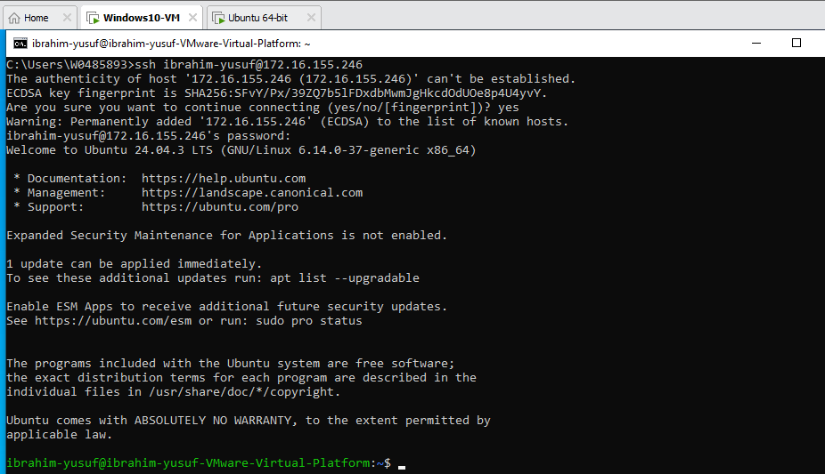
Questions
- Why should only required services be allowed between network segments? To reduce the attack surface. Allowing unnecessary ports or services increases the number of potential entry points that attackers can exploit.
- How does this reduce risk during an incident? By preventing attackers or malware from using unauthorized communication channels to move across the network. Segmentation ensures that only specific types of traffic are permitted, thereby reducing the likelihood of the attack spreading to other systems.
Part 4 – Simulate a Quarantine Network
Step 1
Block all traffic from the Windows system:
“sudo ufw deny from 172.16.155.107” to block all traffic from the Windows VM
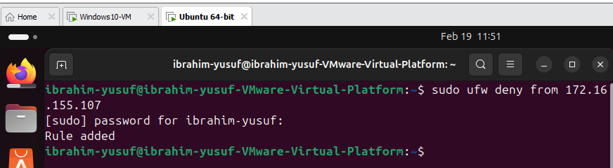
Connecting using SSH from Windows VM
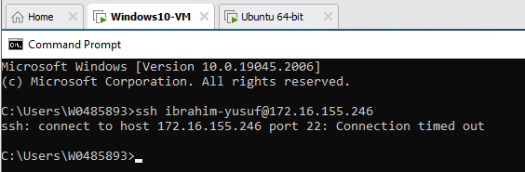
Test connectivity again from Windows. Connectivity failed
Questions
- How does this simulate a quarantine VLAN? Blocking all the traffic from the Window’s 10 VM isolates it from the rest of the network, preventing it from communicating with other devices.
- Why should infected systems remain powered on during an incident? To preserve volatile data such as running processes, network connections, and memory contents. This information will help the incident response team understand the nature of the attack.
- How does containment reduce ransomware spread? By preventing the infected system from accessing shared drives, network resources, or other devices that ransomware could encrypt.
- Why is segmentation critical for incident response? It allows security teams to isolate affected systems without shutting down the entire network. This minimizes operational disruption while enabling faster containment and remediation of threats.

